**San Francisco Bay University**

**CS483 - Fundamentals of Artificial Intelligence**

**2022 Summer Quiz #1**

**Student Name: Mahmud Hamed omer Student ID: 19660**

**Instruction:**

1. **Put your answer right after each question in the answer sheet**

1. Assuming two-features (and ) binary labelled Y dataset and the boundary line of classification shown as follows, try to figure out the hypothesis function, loss function and cost function for the training model. After that, please write pseudo code to find all coefficients in hypothesis function by the method of gradient descent algorithm

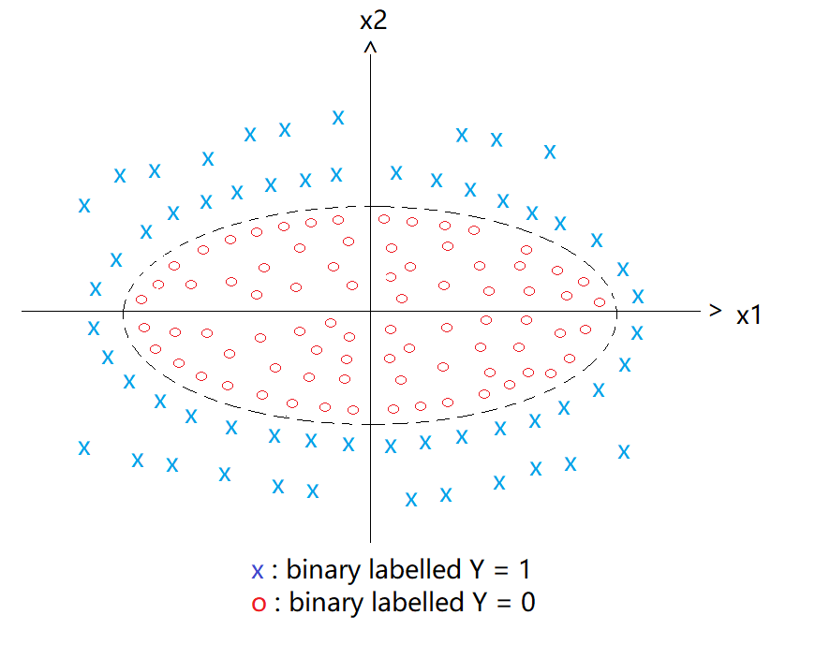

**Solution:**

* **Hypothesis Function:**

For the given problem, the hypothesis function can be derived from the boundary equation, which is an ellipse equation in this case, where any value of the function that falls within the ellipse is categorized under the category Y = 0 (o) and any value of the function that falls outside of the ellipse is categorized under the y = 1 ( x) category. The equations can be derived as follows:

An **ellipse** **equation** whose **center** is at the origin **(0, 0)** and the x1 and x2 intercepts are **a** and **b** respectively, is given by the equation

**Boundary decision function =**  = 1

= + - = 0

*Let , ,*

*Hence, the* ***hypothesis function*** *can be written in terms of theta values as follows*

*+ +*

**Hypothesis function:**

**Loss function**:

=

Where

**Cost function:**

=

**Partial derivative function:**

=

= *

= *

**Then we can use the gradient decent algorithm to find the coefficients:**

After obtaining the hypothesis function coefficients, we can get the value for a and b, and hence, the ellipse boundary equation can be completed.

: Pseudocode

1. Obtain the boundary function
2. Obtain the loss function
3. Calculate the cost function
4. Get the partial derivative of the cost function
5. Use the gradient decent algorithm to find the coefficients of the hypothesis function
6. Get the values of a and b to obtain the boundary function

2. K-means is one of the algorithms in the unsupervised learnings. Please explain intuitively or mathematically why the number of data samples in each cluster will be fixed, known as convergence as well after many iterations of reorganizing each cluster for a certain K’s value.

**Ans:**

In K-means clustering, the objective is to classify the data into K-clusters where all the data inside any cluster are expected to be as close as possible to each other and the clusters to be as far as possible from each other. Hence, after several iterations each data point converges to the nearest cluster and any further iterations can’t bring about any further classification as the data points are static.



As long as the data points are fixed (not moving), any further iterations can’t change the clusters to which the data points belong after convergence, as the data points are as nearest as possible to the cluster center to which they belong comparing to any other cluster center. As distance is fixed